**Exercise Weeks 6/7_6 (Initializing Pointers)**

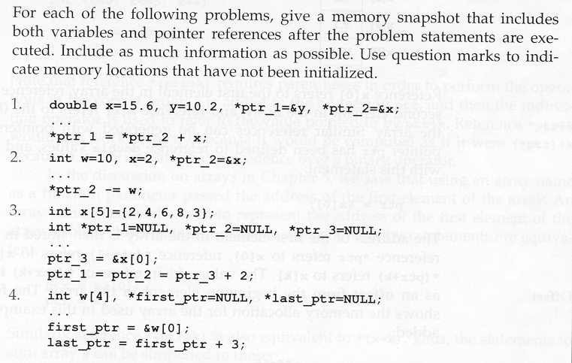

Notation for memory snapshot:

contents

identifier

Memory address

1. double x=15.6, y=10.2, *ptr_1=&y, *ptr_2=&x;

ptr_2

x

y

ptr_1

?

&x

&y

?

10.2

&y

&x

15.6

*ptr_1 = *ptr_2 + x;

ptr_2

x

y

ptr_1

?

&x

&y

?

31.2

&y

&x

15.6

1. int w=10, x=2, *ptr_2=&x;

w

x

ptr_2

&x

?

2

&x

&w

10

*ptr_2 -= w;

w

x

ptr_2

&x

?

-8

&x

&w

10

1. int x[5] = {2,4,6,8,3}

int *ptr_1=NULL, *ptr_2=NULL, *ptr_3=NULL;

X[4]

x+4

3

X[3]

8

X[2]

6

X[1]

4

X[0]

2

x

x+1

x+2

x+3

ptr_1

ptr_2

ptr_3

NULL

?

NULL

?

?

NULL

ptr_3 = &x[0];

ptr_1 = ptr_2 = ptr_3 + 2;

X[4]

x+4

3

X[3]

8

X[2]

6

X[1]

4

X[0]

2

x

x+1

x+2

x+3

ptr_1

ptr_2

ptr_3

x

?

x+2

?

?

x+2

1. int w[4], *first_ptr=NULL, *last_ptr=NULL;

w[3]

?

w[2]

?

w[1]

?

w[0]

?

w

w+1

w+2

w+3

NULL

?

?

NULL

last_ptr

first_ptr

first_ptr = &w[0];

last_ptr = first_ptr + 3;

w[3]

?

w[2]

?

w[1]

?

w[0]

?

w

w+1

w+2

w+3

w

?

?

w+3

last_ptr

first_ptr

**Exercise Weeks 6/7_10 (Dynamic Memory Allocation)**

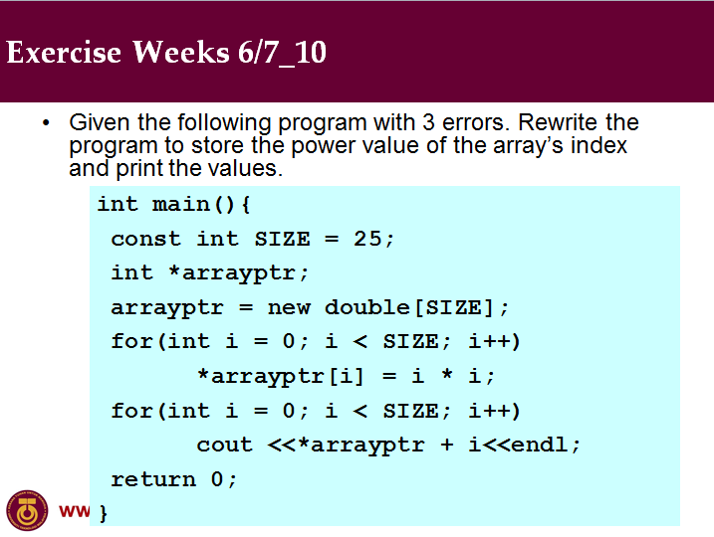

int main () {

const int SIZE = 25;

int *arrayptr;

arrayptr = new int[SIZE];

for(int i = 0; i < SIZE; i++)

arrayptr[i] = i * i;

for(int i = 0; i < SIZE; i++)

cout << *(arrayptr + i) << endl;

return 0;

}